Bataille Kritik – Celebrating Excess Index
Bataille Kritik – Celebrating Excess Index 1
1NC Shell page 1 of 5 2
1NC Shell page 2 of 5 3
1NC Shell page 3 of 5 4
1NC Shell page 4 of 5 5
1NC Shell page 5 of 5 6
Corn Subsidies Link 7
Accumulation Link 9
Genocidal Logic MPX 11
Zero Sum MPX 12
Labor MPX 13
Capitalism MPX 14
Ethic of Squandering Alternative 15
Alt: Consume pointlessly – page 1 of 2 16
Alt: Consume pointlessly – page 2 of 2 17
Alt: Sacrifice or festival. This is the money card. 18
Sacrifice Solvency 19
AT: Authenticity Permutation 20
AT: You’re Not Sacrificing 22

Aff Answer: Bataille is too utopian 23
Aff Answer: Bataille’s approach has no social importance 24
Aff Answer: Bataille’s Methodology of Sacrifice is Flawed 25
Aff Answer: Discouse is Inaccessible and unpragmatic 26
Aff Answer: Racial Realism Supersedes the K 28
Aff Answer: Black Feminism Supersedes Postmodern Kritik 29
Aff: Transgression is Socially Irresponsible; Compassion is a Better Alt 31
Aff: Compassion Alternative -- AT: Sentimental and sickly 32
Aff: Compassion Alternative – Transgression is Insufficient Experience 33
Aff: Transgression cannot recognize difference in mind-body experiences 34
Aff: Gender K of Transgression vs. Compassion Alternatives 35
AT: Do Both Transgression and Compassion 36

Hingstman 33

1NC Shell page 1 of 5

The affirmative ignores the material reality, and instead seeks to address an immediate problem which it encounters, this failure produces errors – the true problem is that we all receive more energy than is needed to survive – this surplus energy must be spent – either it can be squandered through the alternative or it can destroy itself catastrophically through the world of the affirmative
Bataille ’91 (Georges, insane librarian, The Accursed Share: An Essay on the General Economy vol. 1 consumption, translated Robert Hurley p. 21 )

General economy link card- the aff ignores the material reality, and thus commits errors

Man's disregard for the material basis of his life still causes him to err in a serious way. Humanity exploits given material resources, but by restricting them as it does to a resolution of the immediate difficulties it encounters (a resolution which it has hastily had to define as an ideal), it assigns to the forces it employs an end which they cannot have. Beyond our immediate ends, mans activity in fact pursues the useless and infinite fulfillment of the universe.

" Of course, the error that results from so complete a disregard does not just concern man's claim to lucidity. It is not easy to realize one's own ends if one must, in trying to do so, carry out a movement that surpasses them. No doubt these ends and this movement may not be entirely irreconcilable; but if these two terms are to be reconciled we must cease to ignore one of them; otherwise, our works quickly turn to catastrophe.

I will begin with a basic fact: The living organism, in a situation determined by the play of energy on the surface of the globe, ordinarily receives more, energy than is necessary for maintaining life; the excess energy (wealth) can be used for the growth of a system (e.g., an organism); if the system can no longer grow, or if the excess cannot be completely absorbed in its growth, it must necessarily be lost without profit; It must be spent, willingly or not, gloriously or catastrophically.

1NC Shell page 2 of 5

The affirmative team not taking the general economy into consideration dooms themselves to catastrophic destructions through wars, only the alternative allows for us to bring about the violence in our own way.

Bataille ’91 (Georges, insane librarian, The Accursed Share: An Essay on the General Economy vol. 1 consumption, translated Robert Hurley p. 23-25 )

Incomprehension does not change the final outcome in the slightest. We can ignore or forget the fact that the ground we live on is little other than a field of multiple destructions. Our ignorance only has this incontestable effect; it causes us to undergo what we could bring about in our own way, if we understood. It deprives us of the choice of an exudation that might suit us. Above all, it consigns men and their works to catastrophic destructions. For if we do not have the force to destroy the surplus energy ourselves, it cannot be used, and, like an unbroken animal that cannot be trained, it is this energy that destroys us; it is we who pay the price of the inevitable explosion.
These excesses of life force, which locally block the poorest economies, are in fact the most dangerous factors of ruination. Hence relieving the blockage was always, if only in the darkest region of consciousness, the object of a feverish pursuit. Ancient societies found relief in festivals; some erected admirable monuments that had no useful purpose; we use the excess to multiply "services" that make life smoother, and we are led to reabsorb part of it by increasing leisure time. But these diversions have always been inadequate: Their existence in excess nevertheless (in certain respects) has perpetually doomed multitudes of human beings and great quantities of useful goods to the destruction of wars. In our time, the relative importance of armed conflicts has even increased; it has taken on the disastrous proportions of which we are aware.
Recent history is the result of the soaring growth of industrial activity. At first this prolific movement restrained martial activity by absorbing the main part of the excess: The development of modern industry yielded the period of relative peace from 1815 to 1914. Developing in this way, increasing the resources, the productive forces made possible in the same period the rapid demographic expansion of the advanced countries (this is the fleshly aspect of the bony proliferation of the factories). But in the long run the growth that the technical changes made possible became difficult to sustain. It became productive of an increased surplus itself. The First World War broke out before its limits were really reached, even locally. The Second did not itself signify that the system could not develop further (either extensively or in any case intensively). But it weighed the possibilities of a halt in development and ceased to enjoy the opportunities of a growth that nothing opposed. It is sometimes denied that the industrial plethora was at the origin of these recent wars, particularly the first. Yet it was this plethora that both wars exuded; its size was what gave them their extraordinary intensity. Consequently, the general principle of an excess of energy to be expended, considered (beyond the too narrow scope of the economy) as the effect of a movement that surpasses it, tragically illuminates a set of facts; moreover, it takes on significance that no one can deny. We can express the hope to avoid a war that already threatens. But in order to do so we must divert the surplus production, either into the rational extension of a difficult industrial growth, or into ' unproductive works that will dissipate an energy that cannot be accumulated in any case. This raises numerous problems, which are exhaustingly complex. One can be skeptical of arriving easily at the practical solutions they demand, but the interest they hold is unquestionable.

1NC Shell page 3 of 5
Our sacrifice of the affirmative team can be seen as a substitution for sacrificing the Leaders or people in authority, it can be taken as a debate economy of squander

Bataille ’91 (Georges, insane librarian, The Accursed Share: An Essay on the General Economy vol. 1 consumption, translated Robert Hurley p. )

And yet the extreme importance of warfare had brought about a significant change for the Aztecs, in the direction of the rationality of enterprise (which introduces, together with the concern for results and for effective force, a beginning of humanity) as against the cruel violence of consumption. While "the king remained in his palace," the court favored the victim (who was given "the honors of a god") with one of the most solemn sacrifices of the year. There is no possibility of a mistake here: This was a sacrifice of substitution. A softening of the ritual had occurred, shifting onto others the internal violence that is the moral principle of consumption. To be sure, the movement of violence that animated Aztec society was never turned more within than without; but internal and external violences combined in an economy that put nothing in reserve. The ritual sacrifices of prisoners commanded the sacrifices of warriors; the sacrificed victims represented at least the sumptuary expenditure of the sacrificer. The substituting of a prisoner for the king was an obvious, if inconsequent, abatement of this sacrificial frenzy,

1NC Shell page 4 of 5

The affirmative’s focus on the restricted economy is always doomed for destruction, only the alt and its focus on the general economy is capable of creating a Copernican transformation in thinking and ethics -

Bataille ’91 (Georges, insane librarian, The Accursed Share: An Essay on the General Economy vol. 1 consumption, translated Robert Hurley p. 26 )

I will simply state, without waiting further, that the extension of economic growth itself requires the overturning of economic principles — the overturning of the ethics that grounds them. Changing from the perspectives of restrictive economy to those of general economy actually accomplishes a Copernican transformation: a reversal of thinking — and of ethics. If a part of wealth (subject to a rough estimate) is doomed to destruction or at least to unproductive use without any possible profit, it is logical, even inescapable, to surrender commodities without return. Henceforth, leaving aside pure and simple dissipation, analogous to the construction of the Pyramids, the possibility of pursuing growth is itself subordinated to giving: The industrial development of the entire world demands of Americans that they lucidly grasp the necessity, for an economy such as theirs, of having a margin of profitless operations. An immense industrial network cannot be managed in the same way that one changes a tire.... It expresses a circuit of cosmic energy on which it depends, which it cannot limit, and whose laws it cannot ignore without consequences. Woe to those who, to the very end, insist on regulating the movement that exceeds them with the narrow mind of the mechanic who changes a tire.

1NC Shell page 5 of 5

Alt solves Military society

The alt is opposed to the military society of the aff –

Bataille ’91 (Georges, insane librarian, The Accursed Share: An Essay on the General Economy vol. 1 consumption, translated Robert Hurley p. 54)

The value of warfare in Mexican society cannot mislead us: It was not a military society. Religion remained the obvious key to its workings. If the Aztecs must be situated, they belong among the warrior societies, in which pure, uncalculated violence and the ostentatious forms of combat held sway. The reasoned organization of war and conquest was unknown to them. A truly military society is a venture society, for which war means a development of power, an orderly progression of empire. It is a relatively mild society; it makes a custom of the rational principles of enterprise, whose purpose is given in the future, and it excludes the madness of sacrifice. There is nothing more contrary to military organization than these squanderings of wealth represented by hecatombs of slaves.

Corn Subsidies LInk

Corn subidies are good, for it diverts government funds, as well as renders portions of land unproductive, allowing for the sacrifice of crops, and can be used to create a shift to the general economy – The problem is that the government needs to start paying out cash and not giving food vouchers – Also the government must force them to sacrifice the most productive acres of their land.

West's Encyclopedia of American Law in 2008,
edition 2. “Agricultural Subsidies.” As cited in the Free Dictionary, http://legal-dictionary.thefreedictionary.com/Agriculture+Subsidies

Another method used by the government to subsidize agricultural products is the combination of target prices, deficiency payments, and mandatory acreage reduction. This approach is used primarily for corn and wheat, the main U.S. grain crops. Under this method, the government sets an ideal price, or target price, for a commodity. If the market price falls below that target price, the government pays the farmer the difference — that is, makes a deficiency payment to the farmer. This prevents the farmer from being forced to sell the product at a price deemed unfairly low by the government, and supports the farmer's income during difficult economic periods. Programs using this method are not mandatory, so the farmer must enlist in one to be involved. In return for a guaranteed minimum income and price stability, the farmer normally is required to take a specified portion of land out of production — that is, make a mandatory acreage reduction — at least for program commodities.
In any given year, it is impossible to predict how expensive the deficiency payment programs will be, because weather conditions and uncontrolled market forces often greatly affect prices. These types of agriculture subsidies often have been quite expensive, especially during years when market prices are low owing to high production and low exports. To reduce the government's cash payments to farmers during one particularly disastrous market swing, the Reagan administration implemented the Payment in Kind (PIK) Program in 1983. Under the PIK Program, instead of paying farmers with cash, the government paid them with certificates good for federal surplus grain. Farmers could then exchange the certificates for actual grain or trade them like stock certificates. PIK, combined with a drought in 1983, succeeded in reducing the cash cost of the deficiency payment programs and the excessive grain surplus.

Poverty link

Poverty must be considered in relation to the general economy, not a restricted economy based on lack. There is always a surplus which can be used to address poverty – for example if there is poverty in India, there is a surplus in the US, in order to stave off war the US must squander its resources to address india’s poverty, instead of squandering it by blowing up iraq.

Bataille ’91 (Georges, insane librarian, The Accursed Share: An Essay on the General Economy vol. 1 consumption, translated Robert Hurley p. )

As for the present historical situation, it is characterized by the fact that judgments concerning the general situation proceed from a particular point of view. As a rule, particular existence always risks succumbing for lack of resources. It contrasts with general existence whose resources are in excess and for which death has no meaning. From the particular point of view, the problems are posed in the first instance by a deficiency of resources. They are posed in the first instance by an excess of resources from the general point of view. Doubtless the problem of extreme poverty remains in any case. Moreover, it should be understood that general economy must also, whenever possible and first of all, envisage the development of growth. But if it considers poverty or growth, it takes into account the limits that the one and the other cannot fail to encounter and the dominant (decisive) character of the problems that follow from the existence of surpluses.
Briefly considering an example, the problem of extreme poverty in India cannot immediately be dissociated from the demographic growth of that country, or from the lack of proportion with its industrial development. India's possibilities of industrial growth cannot themselves be dissociated from the excesses of American resources. A typical problem of general economy emerges from this situation. On the one hand, there appears the need for an exudation; on the other hand, the need for a growth. The present state of the world is defined by the unevenness of the (quantitative or qualitative) pressure exerted by human life. General economy suggests, therefore, as a correct operation, a transfer of American wealth to India without reciprocation. This proposal takes into account the threat to America that would result from the pressure — and the imbalances of pressure — exerted in the world by the developments of Hindu life.
These considerations necessarily give first priority to the problem of war, which can be clearly regarded only in the light of a fundamental ebullition. The only solution is in raising the global standard of living under the current moral conditions, the only means of absorbing the American surplus, thereby reducing the pressure to below the danger point.

Accumulation Link

Attempts at management and stabilization always fail for there is always an unproductive element which defies utility and can not be grasped.

Bataille ’91 (Georges, insane librarian, The Accursed Share: An Essay on the General Economy vol. 1 consumption, translated Robert Hurley p. 72-73)

While the resources he controls are reducible to quantities of energy, man is not always able to set them aside for a growth that cannot be endless or, above all, continual. He must waste the excess, but he remains eager to acquire even when he does the opposite, and so he makes waste itself an object of acquisitions Once the resources are dissipated, there remains the prestige acquired by the one who wastes. The waste is an ostentatious squandering to this end, with a view to a superiority over others that he attributes to himself by this means. But he misuses the negation he makes of the utility of the resources he wastes, bringing into contradiction not only himself but man's entire existence. The latter thus enters into an ambiguity where it remains: It places the, value, the prestige and the truth of life in the negation of the servile use of possessions but at the same time it makes servile use of this negation. On the one hand, in the useful and graspable thing it discerns that which, being necessary to it, can be used for its growth (or its subsistence), but if strict necessity ceases to bind it, this "useful thing" cannot entirely answer to its wishes. Consequently, it calls for that which cannot be grasped, for the useless employment of oneself, of one's possessions, for play, but it attempts to grasp that which it wished to be ungraspable, to use that whose utility it denied. It is not enough for our left hand not to know what the right hand gives: Clumsily, it tries to take it back.

WAR MPX

Bataille proleptically discusses the problems of American capitalism and how its strive for peace is the unconscious desire for war -

Bataille ’91 (Georges, insane librarian, The Accursed Share: An Essay on the General Economy vol. 1 consumption, translated Robert Hurley p. 171-172)

In a fundamental sense, it is from the side of exuberant production that the danger of war comes: If exportation is difficult, and if no other outlet is open, only war can be the client of a plethoric industry. The American economy is in fact the greatest explosive mass the world has ever known. True, its explosive pressure is not favored as it was in Germany, both externally by the proximity of dense military populations and internally by a disequilibrium between the different parts of the development of the productive forces. In return, the idea that that enormous machinery, driven by an inevitable movement of growth, is viable — balanced and rational — implies all the dangers of thoughtlessness. The fact that it was discharged in two world wars is not especially reassuring. In any case it is painful to see a dynamic society given over unreservedly and without long-range plans to the movement that propels it. It is painful to know that it is largely unacquainted with the laws of its development and that it produces without assessing the consequences of the production. This economy was capable of two wars; assuming its movement of growth continues, what sudden spell might make it capable of peace? Those who keep it running are naively convinced of having no other purpose. But should they not be asked whether they are not unconsciously pursuing the opposite of what their consciousness admits? The Americans are used to seeing others start wars, and experience has shown them the advantage of waiting

Growth and development always produce a surplus which if not spent will end in wars – WWI and II prove

Bataille ’91 (Georges, insane librarian, The Accursed Share: An Essay on the General Economy vol. 1 consumption, translated Robert Hurley p. )

In actual fact the quantitative relations of population and tool-making — and, in general, the conditions of economic development in history — are subject to so many interferences that it is always difficult to determine their exact distribution. In any case, I cannot incorporate detailed analyses into an overall survey that seems the only way of outlining the vast movement which animates the earth. But the recent decline in demographic growth by itself reveals the complexity of the effects. The fact is that the revivals of development that are due to human activity, that are made possible or maintained by new techniques, always have a double effect: Initially, they use a portion of the surplus energy, but then they produce a larger and larger surplus. This surplus eventually contributes to making growth more difficult, for growth no longer suffices to use it up. At a certain point the advantage of extension is neutralized by the contrary advantage, that of luxury the former remains operative, but in a disappointing — uncertain, often powerless,— way. The drop in the demographic curves is perhaps the first indicator of the change of sign that has occurred: Henceforth what matters primarily is no longer to develop the productive forces but to spend their products sumptuously.

At this point, immense squanderings are about to take place. After a century of populating and of industrial peace, the temporary limit of development being encountered, the two world wars organized the greatest orgies of wealth — and of human beings — that history has recorded. Yet these orgies coincide with an appreciable rise in the general standard of living: The majority of the population benefits from more and more unproductive ser- vices; work is reduced and wages are increased overall.

Genocidal Logic MPX

Relying on the restricted economy leads to genocidal logic of blood for oil

Harney and Martin ‘07(Stefano & Randy The Johns Hopkins University Press,Mode of Excess: Bataille, Criminality, and the War On Terror/muse)

  - Specifically, blood for oil is a pipeline that has smuggled in a Malthusian logic of genocidal scarcity. The argument goes like this. The days of expanding oil supply are behind us. The rate at which new wells are drilled has been eclipsed by the rate at which new demand has expanded, in consequence, a bell-shaped forecast named for the geo-physicist who made it, "Hubbert's Peak," pinpoints the date of diminishing returns. Population growth assures that there will not be enough oil to go around. Security for the imperium dictate that it grabs hold of whatever remains. Oil and war are fraternal twins. Yet Hubbert's peak, so pointed in sounding the alarm, is also vulnerable on its own economic foundations. As oil prices rise, abandoned fields again become profitable, along with the rationale for further investment to extract oil from otherwise unappealing shale. The conflation of access to oil with control of its sources certainly lines up with imperial history. But that history discloses how the very regimes installed to control oil territories repress domestic populations and wind up destabilizing access, a lesson reflected in the fully financialized oil futures markets by meeting volatility with arbitrage.^{i}
Zero Sum MPX

Excess can either be spent on war or it can be squandered in other ways – its zero sum
Harney and Martin ‘07(Stefano & Randy The Johns Hopkins University Press,Mode of Excess: Bataille, Criminality, and the War On Terror /muse)

War is the consummate category of expenditure that can be stolen back by state and particularizing economic exchange, especially as it seeks an equilibrium between destruction and profit in what is intended as a virtuous cycle of demand absorbing supply that Franklin Delano Roosevelt dubbed, "Dr. Win The War." Like the partition between production and consumption, this political economy of war assumes that death and profitability belong to separate accounts, and that civic devastation will be restored by a reincorporating policy framework like the Marshall Plan. As Bataille observes: "Of course, what we spend in one category is in principle lost for the others. There are many possibilities of slippage: alcohol, war and holidays involve us in eroticism, but this means simply that the possible expenditures in one category are ultimately reduced by those we make in the others, so that only the profits found in war truly alter this principle; even so, in most cases these profits correspond to the losses of the vanquished.... We need to make a principle of the fact that sooner or later the sum of excess energy that is managed for us by a labor so great that it limits the share available for erotic purposes will be spent in a catastrophic war."(Bataille 1993: 188) Under these circumstances, the political choice becomes clear, expenditure can be wasted in war or applied to increase the standard of living.

Labor MPX

Where there is labor humans will be reduced to the status of things, in which it becomes reduced to its use value -
Bataille ’91 (Georges, insane librarian, The Accursed Share: An Essay on the General Economy vol. 1 consumption, translated Robert Hurley p. 57)

In the same way, slavery brings into the world the absence of light that is the separate positing of each thing, reduced to the use that it has. Light, or brilliance, manifests the intimacy of life, that which life deeply is, which is perceived by the subject as being true to itself and as the transparency of the universe.
But the reduction of "that which is" to the order of things is not limited to slavery. Slavery is abolished, but we ourselves are aware of the aspects of social life in which man is relegated to the level of things, and we should know that this relegation did not await slavery. From the start, the introduction of labor into the world replace intimacy, the depth of desire and its free outbreaks with rational progression, where what matters is no longer the truth of the present moment but rather the subsequent results, of operations. The first labor established the world of things, to which the profane world of the Ancients generally corresponds. Once the world of things was posited, man himself became one of the things of this world, at least for the time in which he labored. It is this degradation that man has always tried to escape. In his strange myths, in his cruel rites man is in search of a lost intimacy from the first.

Capitalism MPX

Subjecthood is impossible under capitalism –

Kosalka ’99 (David, University of Wisconsin, Milwaukee Historian Underground: Making History Relevant For Life, Georges Bataille and the Notion of Gift)

Thus with capitalist society Bataille saw an essential abdication of the search for subjective meaning in the expenditure of success, a phenomenon well documented to in the contemporary situation. The needed outlet of expenditure is provided in the controlled environment of strip malls, providing the small and directed release necessary to avoid an outright explosion. The individual is marginalized as spectator, sharing symbolically in the expulsion of excess found in sports and talk shows. As Laura Marz has emphasized, "the spectacle steals every experience and sells it back to us, but only symbolically, so that we are never satisfied: via this mechanism we support the machine of endless consumption over and over." Subjecthood is lost to a system of production and consumption. It does not allow for the kind of expression of personal power and subjecthood found in the gift. The nature of the expenditure does not come from a personal, intimate, relation to the subject, but is rather given to the consumer by the large corporations operating on an economy of scale. The personal and human, as was found in Bataille's considerations of Aztec sacrifice, is entirely absent in a pre-given impersonal world of the suburbs. Thus, there is no personal escape into the realm of the sacred subject.

Ethic of Squandering Alternative
Blanket condemnations of violence, ignore who we fundamentally are – The acts the affirmative abhors are also the acts that they most celebrate - live revolves around the general economy of how to spend surplus energy we need an ethics of squandering what is good in order to truly come to terms of who we are.
Itzkowitz ‘ 99 (Kenneth associate professor of philosophy at Marietta College. He has written mainly on issues of continental value theory, ethics, and violence at the end of metaphysics, To witness spectacles of pain: The hypermorality of Georges Bataille)
It would be pointless to deny that most illegal violence is abhorrent or immoral. At the same time, however, given the violence of the life of our culture, we need to understand immoral violence more deeply than any blanket condemnation of it will allow. Beyond our condemnations, we need to recognize that the acts we most prohibit are paradoxically also the very ones we most celebrate. A foremost proponent of this need is the French philosopher and writer Georges Bataille. Relying on a notion of excess energy and the problem of its expenditure, Bataille argues that the transgression of law is what he calls an accursed yet ineluctable part of our lives. We make laws in the name of prohibiting acts of violence, yet the problem of the expenditure of an excess of energy requires behaviors that violate the very same rules we cherish and intend to uphold. The commentator Jean Piel took note of how Bataille managed "to view the world as if it were animated by a turmoil in accord with the one that never ceased to dominate his personal life" (1995, 99). Here, the fact of an individual in-turmoil reflects the surplus of energy disturbing life in general, rather than a moral deficiency for which an individual can be held accountable. For Bataille, an individual's wasteful behaviors are ultimately reflections of the problem of the surplus of solar energy. Piel put it this way: "The whole problem is to know how, at the heart of this general economy, the surplus is used" (1995, 103). How should the surplus of solar energy be used? Bataille contends that this surplus is never extinguished and that its expenditure always leads towards the commission of violence. The surplus of energy is accursed and finally cannot serve us productively. The accursed excess confronts us with the problem of how to expend energy when this results in usages that cannot made be useful. Thus the production of violence has a value for us as those condemned to the realm of non-productive expenditures. We undoubtedly deny this value, as Bataille notes, when "Under present conditions, everything conspires to obscure the basic movement that tends to restore wealth to its function, to giftgiving, to squandering without reciprocations" (1988, 38). Nonetheless, as Bataille puts it, "the impossibility of continuing growth makes way for squander" (1988, 29). When this impossibility of useful expenditure is ignored, then we fail to recognize ourselves on the deepest level, as who we most fundamentally are.
Against this failure and in the name of a kind of inverted Hegelian selfrecognition, Bataille calls for the transgression of our prohibitionist moral values. We need an ethics of squandering goods, of squandering what is good, in recognition of an overabundance over and beyond all others, i.e. an overabundance that can only, at best, be squandered. He writes, life suffocates within limits that are too close; it aspires in manifold ways to an impossible growth; it releases a steady flow of excess resources, possibly involving large squanderings of energy. The limit of growth being reached, life . . . enters into ebullition: Without exploding, its extreme exuberance pours out in a movement always bordering on explosion. (Bataille 1988, 30)

Alt: Consume pointlessly – page 1 of 2

Georges Bataille (an insane librarian). Theory of Religion. 1989. Translated by Robert Hurley. Page 97-104.

The authenticity of a use of science adapted to a knowledge of the intimate order immediately rules out the possibility of giving a learned form to the autonomous declarations of men of intimacy. In the relationship between objective knowledge and intimacy there is doubtless a primary difference: the object can always expect the light that will illuminate it whereas intimacy seeking the light cannot expect it to be projected correctly. If the restoration of the intimate order is to be achieved in the sphere of clear consciousness, which alone has the force to rescue intimacy from equivocations, it still cannot be achieved through a suspension of intimate existence. And insofar as the will to clear consciousness is involved, intimacy will appear to be immediately given in the sphere of distinct knowledge. The difficulty of making distinct knowledge and the intimate order coincide is due to their contrary modes of existence in time. Divine life is immediate, whereas knowledge is an operation that requires suspension and waiting. Answering to the temporal immediacy of the divine life, there was myth and the forms of equivocal thought. And intimate experience can doubtless abandon mysticism, but every time it take place it must be a complete answer to a total question.
This being true, no one can correctly answer the requirement given in the forms of objective knowledge except by positing a non-knowledge. Irrespective of the fact that the affirmation of a fundamental non-knowledge may be justified on other grounds, the clear consciousness of what is at stake immediately ties divine life to a recognition of its obscure nature, of the night that it opens to discursive knowledge. This immediate coincidence of clear consciousness and the unfettering of the intimate order is not just manifested in the negation of traditional presuppositions; it implies the hypothesis formulated once and for all: “Intimacy is the limit of clear consciousness; clear consciousness cannot clearly and distinctly know anything concerning intimacy, except for the modifications of things that are linked to it.” (We don't know anything concerning anguish except insofar as it is implied in the fact of the impossible operation.) Self-consciousness thus escapes the dilemma of the simultaneous requirement of immediacy and of the operation. The immediate negation diverts the operation toward things and toward the domain of duration.
The weakness of traditional understandings of the intimate order resides in the fact that they have always involved it in the operation; they have either attributed the operative quality to it, or they have sought to attain it by way of the operation. Man placing his essence in the operation obviously cannot bring it about that there is not some link within him between the operation and intimacy. It would be necessary either for intimacy or for the operation to be eliminated. But, being reduced to thinghood by the operation, all that he can do is to undertake the contrary operation, a reduction of the reduction.
In other words, the weakness of the various religious positions is in having undergone the debasement of the order of things without having tried to modify it. Without exception, the religions of mediation left it as it was, countering it only with the limits of morality. Like the archaic religions, they expressly proposed to maintain it, never lifting it unless they had first ensured its stability. In the end, the reality principle triumphed over intimacy.

What is required by self-consciousness is not really the destruction of the order of things. The intimate order cannot truly destroy the order of things (just as the order of things has never completely destroyed the intimate order). But this real world having reached the apex of its development can be destroyed, in the sense that it can be reduced to intimacy. Strictly speaking, consciousness cannot make intimacy reducible to it, but it can reclaim its own operations, recapitulating them in reverse, so that they ultimately cancel out and consciousness itself is strictly reduced to intimacy. Of course this counter operation is not in any way opposed to the movement of consciousness reduced to that which it essentially is – to that which, from the start, each one of us always knew it was. But this will be clear consciousness only in one sense. It will regain intimacy only in darkness. In so doing, it will have reached the highest degree of distinct clarity, but it will so fully realize the possibility of man, or of being, that it will rediscover the night of the animal intimate with the world – into which it will enter.

Alt: Consume pointlessly – page 2 of 2

THE GENERAL DESTRUCTION OF THINGS
To begin with, we have clear consciousness in its elaborated form. Further, the world of production, the order of things, has reached the point of development where it does not know what to do with its products. The first condition makes destruction possible; the second makes it necessary. But this cannot be done in the empyrean, that is, in unreality, to which the religious approach usually leads. The moment of decision demands, on the contrary, a consideration of the poorest and least intimate aspects of the problem. We must descend now to the lower level of the world of man's reduction to thinghood.
I can shut myself up in my room, and look there for the clear and distinct meaning of the objects that surround me. Here is my table, my chair, my bed. They are here as a result of labor. In order to make them and install them in my room it was necessary to forego the interest of the moment. As a matter of fact I myself had to work to pay for them, that is, in theory, I had to compensate for the labor of the workers who made them or transported them, with a piece of labor just as useful as theirs. These products of labor allow me to work and I will be able to pay for the work of the butcher, the baker, and the farmer who will ensure my survival and the continuation of my work.
Now I place a large glass of alcohol on my table.
I have been useful. I have bought a table, a glass, etc.
But this table is not a means of labor: it helps me to drink alcohol.
In setting my drinking glass on the table, to that extent I have destroy the table, or at least I have destroyed the labor that was needed to make it.
Of course I have first completely destroyed the labor of the winegrower, whereas my absorption has only destroyed a minute amount of the carpenter's labor. At least this table in this room, heavy with the chains of labor, for a time had no other purpose than my breaking loose.

I am now going to recall the use I have made of the money earned at my work table.
If I have wasted part of that money, wasted part of the time the rest enabled me to live, the destruction of the table is already more advanced. Had I just once seized the moment by the hair, all the preceding time would already be in the power of that moment seized. And all the supplied, all the jobs that allowed me to do so would suddenly be destroyed; like a river, they would drain endlessly into the ocean of that brief instant.
In this world there is no immense undertaking that has any other end than a definitive loss in the futile moment. Just as the world of things is nothing in the superfluous universe where it is dissolved, the mass of efforts is nothing next to the futility of a single moment. The free yet submissive moment, furtively involved in minute operations by the fear of letting oneself lose time is what justifies the pejorative value of the word futile.
This introduces, as the basis for clear self-consciousness, a consideration of the objects that are dissolved and destroyed in the intimate moment. It is a return to the situation of the animal that eats another animal; it is a negation of the difference between the object and myself or the general destruction of objects as such in the field of consciousness. Insofar as I destroy it in the field of my clear consciousness, this table ceases to form a distinct and opaque screen between the world and me. But this table could not be destroyed in the field of my consciousness if I did not give my destruction its consequences in the real order. The real destruction of the reduction of the real order brings a fundamental reversal into the economic order. If we are to preserve the movement of the economy, we need to determine the point at which the excess production will flow like a river to the outside. It is a matter of endlessly consuming – or destroying – the objects that are produced. This could just as well be done without the least consciousness. But it is insofar as clear consciousness prevails that the objects actually destroyed will not destroy humanity itself. The destruction of the subject as an individual is in fact implied in the destruction of the object as such, but war is not the inevitable form of the destruction: at any rate, it is not the conscious form (that is, if self-consciousness is to be, in the general sense, human).

Alt: Sacrifice or festival. This is the money card.

Georges Bataille (an insane librarian). Theory of Religion. 1989. Translated by Robert Hurley. Page 43-44.

The first fruits of the harvest or a head of livestock are sacrificed in order to remove the plant and the animal, together with the farmer and the stock raiser, from the world of things.
The principle of sacrifice is destruction, but though it sometimes goes so far as to destroy completely (as in the holocaust), the destruction that sacrifice is intended to bring about is not annihilation. The thing – only the thing – is what sacrifice means to destroy in the victim. Sacrifice destroys an object's real ties of subordination; it draws the victim out of the world of utility and restores it to that of unintelligible caprice. When the offered animal enters the circle in which the priest will immolate it, it passes from the world of things which are closed to man and are nothing to him, which he knows from the outside – to the world that is immanent to it, intimate, known as the wife is known in sexual consumption. This assumes that it has ceased to be separated from its own intimacy, as it is in the subordination of labor. The sacrificer's prior separation from the world of things is necessary for the return to intimacy, of immanence between man and the world, between the subject and the object. The sacrificer needs the sacrifice in order to separate himself from the world of things and the victim could not be separated from it in turn if the sacrificer was not already separated in advance. The sacrificer declares: “Intimately, I belong to the sovereign world of the gods and myths, to the world of violent and uncalculated generosity, just as my wife belongs to my desires. I withdraw you, victim, from the world in which you were and could only be reduced to the condition of a thing, having a meaning that was foreign to your intimate nature. I call you back to the intimacy of the divine world, of the profound immanence of all that is.”

Sacrifice Solvency

Sacrificing the crops is the only way to reach the divine, the aff merely operates under the paradigm of the profane –

Bataille ’91 (Georges, insane librarian, The Accursed Share: An Essay on the General Economy vol. 1 consumption, translated Robert Hurley p. 120-121)

Religious activities — sacrifices, festivals, luxurious amenities — absorb the excess energy of a society, but a secondary efficacy is usually attributed to a thing whose primary meaning was in breaking the chain of efficacious actions. This results in a great malaise — a feeling of wrong, of dupery — which pervades the religious sphere. A sacrifice in view of a crude result, such as fertility of the fields, is experienced as a commonplace action at the level of the divine, of the sacred, which religion calls into play. In theory, salvation in Christianity liberates the ends of religious life from the domain of productive activity. But if the faithful's salvation is the reward for his merits, if he can achieve it by his deeds, then he has simply brought more closely into the domain of religion the concatenation that makes useful work wretched in his eyes. Hence those deeds by which a Christian tries to win his salvation can in turn be considered profanations. Even the mere fact of choosing salvation as a goal appears contrary to the truth of grace. Grace alone brings about an accord with the divinity, which cannot be subjected to casual series as things can. The gift that divinity makes of itself to the faithful soul cannot be paid for.

Offering the sacrifice allows for us to become sovereign subjects – in which we can consume profitless the affirmative which has been regulated to utilitarian usefulness

Kosalka ’99 (David, University of Wisconsin, Milwaukee Historian Underground: Making History Relevant For Life, Georges Bataille and the Notion of Gift)
Symbolically, along with the object itself, the one who offers the sacrifice is seen as removed from the demands of utility and consequently as possibly a sovereign subject. Those who offer the sacrifice are not completely dominated by the needs of the system or the process, but, rather, can exist free of their constraints in the moment of the sacrifice. Bataille examines these notions in light of Aztec sacrifice. While to modern sensibilities the immense level of human sacrifice in that culture seems an abomination, it represents the nature of sacrifice. In the words of Bataille, "The victim is surplus taken from the mass of useful wealth. And he can only be withdrawn from it in order to be consumed profitlessly, and therefore utterly destroyed. Once chosen, he is the accursed share, destined for violent consumption. But the curse tears him away from the order of things; it gives him a recognizable figure, which now radiates intimacy, anguish, the profundity of living beings."
AT: Authenticity Permutation
AT: You’re trying to win/educate/whatever. Referring back to the festival, we posit its ends and its solvency, but this can’t capture/diminish the momentary, orgiastic intimacy of it.

Georges Bataille (an insane librarian). Theory of Religion. 1989. Translated by Robert Hurley. Page 54-57.

The festival is the fusion of human life. The thing and the individual, it is the crucible where distinctions melt in the intense heat of intimate life. But its intimacy is dissolved in the real and individualized positing of the ensemble that is at stake in the rituals. For the sake of a real community, of a social fact that is given as a thing – of a common operation in view of a future time – the festival is limited: it is itself integrated as a link in the concatenation of useful works. As drunkenness, chaos, sexual orgy, that which it tends to be, it drowns everything in immanence in a sense, it then even exceeds the limits of the hybrid world of spirits, but its ritual movements slip into the world of immanence only through the mediation of spirits. To the spirits borne by the festival, to whom the sacrifice is offered, and to whose intimacy the victims are restored, an operative power is attributed in the same way it is attributed to things. In the end the festival itself is viewed as an operation and its effectiveness is not questioned. The possibility of producing, of fecundating the fields and the herds is given to rites whose least servile operative forms are aimed, through a concession, at cutting the losses from the dreadful violence of the divine world. In any case, positively in fecundation, negatively in propitiation, the community first appears in the festival as a thing, a definite individualization and a shared project with a view to duration. The festival is not a true return to immanence but rather an amicable reconciliation, full of anguish, between the incompatible necessities.
Of course the community in the festival is not posited simple as an object, but more generally as a spirit (as a subject-object), but its positing has the value of a limit to the immanence of the festival and, for this reason, the thing aspect is accentuated. If the festival is not yet, or no longer, under way, the community link to the festival is given in operative forms, whose chief ends are the products of labor, the crops, and the herds. There is no clear consciousness of what the festival actually is (of what it is at the moment of its letting loose) and the festival is not situated distinctly in consciousness except as it is integrated into the duration of the community. This is what the festival (incendiary sacrifice and the outbreak of fire) is consciously (subordinated to that duration of the common thing, which prevents it from enduring), but this shows the festival's peculiar impossibility and man's limit, tied as he is to clear consciousness. So it is not humanity – insofar as clear consciousness rightly opposes it to animality – restored to immanence. The virtue of the festival is not integrated into its nature and conversely the letting loose of the festival has been possible only because of this powerlessness of consciousness to take it for what it is. The basic problem of religion is given in this fatal misunderstanding of sacrifice. Man is the being that has lost, and even rejected, that which he obscurely is, a vague intimacy. Consciousness could not have become clear in the course of time if it had not turned away from its awkward contents, but clear consciousness it itself looking for what it has itself lost, and what it must lose again as it draws near to it. Or course what it has lost is not outside it; consciousness turns away from the obscure intimacy of consciousness itself. Religion, whose essence is the search for lost intimacy, comes down to the effort of clear consciousness which wants to be a complete self-consciousness: but this effort is futile, since consciousness is no longer an operation whose outcome implies duration, that is, at the level where clarity, which is the effect of the operation, is no longer given.

AT Permutation-- Statism

A2 – The perm – Their reliance on the state merely serves to conceal the excess which exists in need of squander

Harney and Martin ‘07(Stefano & Randy The Johns Hopkins University Press,Mode of Excess: Bataille, Criminality, and the War On Terror/muse)

Whatever the cornucopia offered by finance, something prevents access to the immanent luxury of the social, something 'destines life's exuberance to revolt,' to rebel against new forms of 'military exploitation, religious mystification, and capitalist misappropriation,' to seek out a more luxuriate mode of excess, a mode of discretion and difference lived by all. (Bataille 1993: 77) A mean and indifferent mode of excess burns off all this self-activity, if not all this revolt, and leaves behind an effect, a state effect. Bataille asks us in his studies to seek out the effects of the accursed share, the state effects that come to trace the state-form. We mean by the state-form something more than the state as it is used as a category by political scientists. We mean something Bataille provokes us to consider. We mean that which becomes visible in the struggle over excess as an economy of excess, that which stands in for the mode of excess itself. So to ask what state-form corresponds to this mean and indifferent mode of excess is to take these state effects as clues, effects produced by a public capacity itself forged in the struggle today to produce capital's division of risk and at risk populations. To produce both the embracing of risk and the sorting of at risk populations that animate both financialization and the war on terror a certain kind of struggle, a certain kind of privatization must be at work. And this work of privatization can be read in the worak left to the state-form.
AT: You’re Not Sacrificing
Our alternative demands not literal death but waste – expenditure for no purpose

Georges Bataille (an insane librarian). Theory of Religion. 1989. Translated by Robert Hurley. Page 45-46.

The puerile unconsciousness of sacrifice even goes so far that killing appears as a way of redressing the wrong done to the animal, miserably reduced to the condition of a thing. As a matter of fact, killing in the literal sense is not necessary. But the greatest negation of the real order is the one most favorable to the appearance of the mythical order. Moreover, sacrificial killing resolves the painful antinomy of life and death by means of a reversal. In fact death is nothing in immanence, but because it is nothing, a being is never truly separated from it. Because death has no meaning, because there is no difference between it and life, and there is no fear of it or defense against it, it invades everything without giving rise to any resistance. Duration ceases to have any value, or it is there only in order to produce the morbid delectation of anguish. On the contrary, the objective and in a sense transcendent (relative to the subject) positing of the world of things has duration as its foundation: no thing in fact has a separate existence, has a meaning, unless a subsequent time is posited, in view of which it is constituted as an object. The object is defined as an operative power only if its duration is implicitly understood. If it is destroyed as food or fuel is, the eater or the manufactured object preserves its value in duration; it has a lasting purpose like coal or bread. Future time constitutes this real world to such a degree that death no longer has a place in it. But it is for this very reason that death means everything to it. The weakness (the contradiction) of the world of things is that it imparts an unreal character to death even though man's membership in this world is tied to the positing of the body as a thing insofar as it is mortal.

Aff Answer: Bataille is too utopian

Bataille’s approach is problematic since it reinforces the Hegelian model of historical development AND HOPES ON A UTOPIAN SOCIETY THAT IS SOLELY ABSENT FROM CAPITALISM
Allan Stoekl, Professor of French and Comparative Literature at Penn State University, Source: “Editor's Preface “ Yale French Studies, No. 78, On Bataille, (1990), pp. 1-6

Aff Answer: Bataille’s approach has no social importance

Bataille’s approach affirms the Hegelian dialectic AND AMOUNTS TO NOTHING
Allan Stoekl, Professor of French and Comparative Literature at Penn State University Source: “Editor's Preface “Yale French Studies, No. 78, On Bataille, (1990), pp. 1-6

BATaILLE’S WRITING IS UNDERDEVELOPED AND HIS CONCEPTS ARE INACCESSIBLE AND UNWORKABLE TO OTHERS
DeBoer Jason 1999, literary and philosophical writer “Bataille versus Theory” “http://www.sauer-thompson.com/essays/Bataille%20Versus%20Theory,%20an%20essay%20by%20Jason%20DeBoer.doc”
Georges Bataille organizes his writings around many core concepts or ideas, many of which remain diffuse and somewhat underdeveloped in their definitions or meanings. Communication, sovereignty, heterology, inner experience, the sacred, dépense or expenditure, transgression, excess, etc.; each concept appears in his texts as a momentary connotation, a brief enunciation that creates an impact in the reader, then disappears before becoming fully ensnared within the parameters of conceptualization. Perhaps it is this vagueness or ambiguity inherent in all of Bataille’s concepts that prevents them from being appropriated by the theoretical mainstream and being put to work in a dogmatic system. In order for an idea to be put to work, for it to be able to perform a function, perhaps it must first have a proper definition... which many of Bataille’s concepts lack. The broadness of his terms (indeed, Bataille’s move from a restrictive to a general economy shows a digression from the specific, from specialization) may keep them from being utilized by others; this subversion of utility arises from the difficulty of pinpointing where or when a Bataillean concept begins or ends. This sacrifice of clarity certainly is an intentional strategy, Bataille’s own “employment” of unworkable concepts. It is within this arena of thought that I wish to examine the contemporary state of theory.
Aff Answer: Bataille’s Methodology of Sacrifice is Flawed

BATAILLES SACRIFICEABLE MODE OF RESISTANCE DOMESTICATES DEATH

Elisabeth Arnould, 1996, Assistant Professor of French Literature at University of Colorado,”The Impossible Sacrifice of Poetry: Bataille and the Nancian Critique of Sacrifice”
What exactly, however, does this sacrificial renunciation of words represent for Bataille and why did he choose to load it with all the transgressive weight of the experience of nonknowledge ("non-savoir")? Why place the self-sacrifice of poetry at the very center of a book that would be annulled by an immolation of speech? Indeed, why make this final "supplice"--a sacrifice of words performed and dedicated "to" "nothing"--into the core of the book's interior rapture? Isn't this figure of death and silence incurably equivocal? Does it not attribute the traditional traits of a "nothingness" to this "rapturous heart" of finitude that Bataille always wanted to designate as the "impossible" object of his experience? And is it not, therefore, condemned to appropriate, through this representation, the nonmeaning of a finitude that Bataille, far from conceptualizing as simple nothingness, usually prefers to designate ambiguously as "nonknowledge"?
Such are the questions I shall address in reevaluating Bataille's concept of sacrifice in light of Jean-Luc Nancy's critique. In his article "The Unsacrificeable," Nancy was the first to point out the problematic nature of the sacrificial model in Bataille's conceptualization of finitude. According to Nancy, sacrifice, including the self-sacrifice of Rimbaud so important to Bataille, is the vehicle of an "ontotheological" appropriation. And it is through sacrifice that Bataille's reflection on finitude attempts to domesticate death while claiming to abandon it to the aporetic enunciation of a "nonknowledge."
SACRIFICE FOR THE SAKE OF SACRIFICING IS REDUNDANT

Elisabeth Arnould, 1996, Assistant Professor of French Literature at University of Colorado,”The Impossible Sacrifice of Poetry: Bataille and the Nancian Critique of Sacrifice”

Let us return to the statement: the works, that is to say, "the goddess to whom we sacrifice is herself sacrifice, tears wept to the point of dying" ("cette déesse à laquelle nous sacrifions est elle-même sacrifice, larmes pleurées jusqu'à en mourir") [IE151, translation modified; EI175]. What are we to make of this tautology? What does it mean "to perform a sacrifice to sacrifice"? One usually sacrifices to a God, to an ideal. One sacrifices, as Proust did, to a work, to a meaning and a truth, in order to produce that meaning and that truth. According to the strange tautology of an intention and a gesture that never coincide, to perform a sacrifice to sacrifice can mean nothing other than to sacrifice for sacrifice. The sacrifice to sacrifice is a sacrifice that can never take place, a sacrifice that performs itself as the impossibility, or as the indefinitely held-up possibility, of its realization. To offer a sacrifice to sacrifice is also to sacrifice sacrifice itself. And the self-sacrifice of Proust not only repeats Rimbaud's negating gesture but also emphasizes its nonmeaning. For this formulation clearly indicates that this last sacrifice is not held up to a sacrificial truth, be it positive or negative, spiritual or immanent. Sacrifice does not sacrifice to the revelation of its nothingness. It sacrifices simply to sacrifice, to the indefinite adjournment of its day of revelation. Like Rimbaud turning away from poetry, it, in the classical sense of the term, apostrophizes ⁶ sacrifice, turns [End Page 94] away, sacrifices to ("in order to" and "to") sacrifice.

Aff Answer: Discouse is Inaccessible and unpragmatic

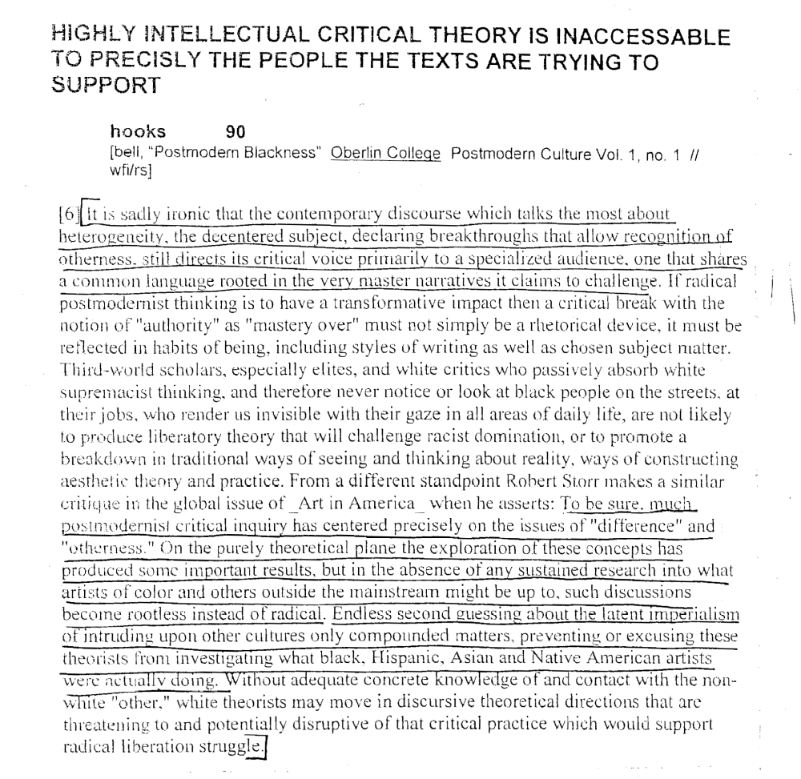
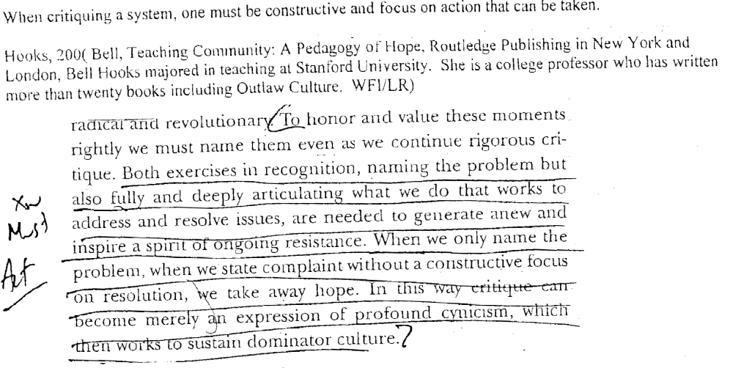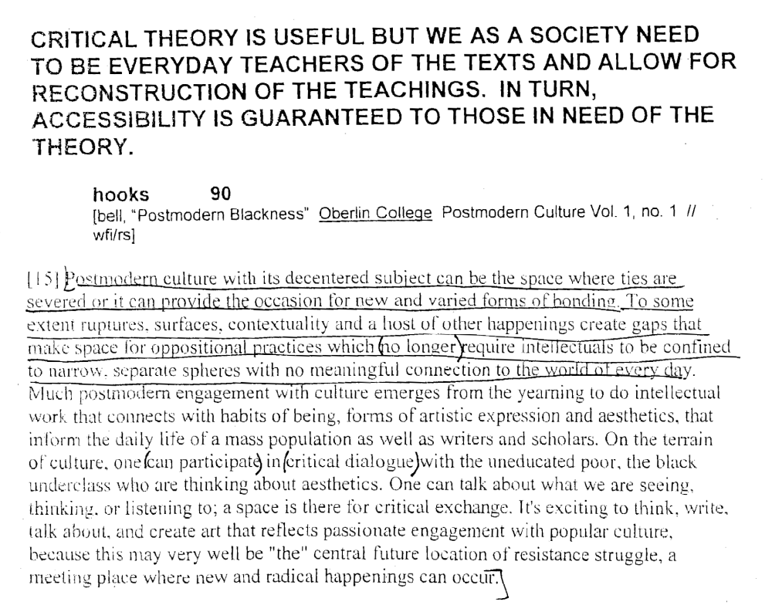

Aff Answer: Racial Realism Supersedes the K

The silence of how white supremacy functions in the kritik perpetuates how it is an invisible unnamed system that has made the modern world what it is today.
Charles Mills, a professor of philosophy at the University of Illinois writes in his book the Racial Contract in 1997 p.1

White supremacy is the unnamed political system that has made the modern world what it is today. You will not find this term in introductory, or even advanced, texts in political theory. A standard undergraduate philosophy will start off with Plato and Aristotle, perhaps say something about Augustine, Aquinas, and Machiavelli, move on to Hobbes, Locke, Mill, and Marx, and then wind up with Rawls and Nozick. It will introduce you to notions of aristocracy, democracy, absolutism, liberalism, representative democracy, socialism, welfare capitalism, and libertarianism. But though it covers more than two thousand years of western political thought and runs the ostensible gamut of political systems, there will be no mention of the basic political system that has shaped the world for the past several hundred years. And this omission is not accidental. Rather, it reflects the fact that standard textbooks and courses have for the most part been written and designed by whites, who take their racial privilege so much for granted that they do not even see it as political, as a form of domination. Ironically, the most important political system of recent global history—the system of domination by which white people have historically ruled over and, in certain important ways, continue to rule over nonwhite people-is not seen as a political system at all. It is jus taken for granted, it is the background against which other systems, which we are to see as political, are highlighted.

White supremacy is at the root of war and eco-crisis.
This is Tim Wise in 2006
It is the American form of white supremacy, still, as with its predecessor rooted in the dichotomization of peoples into good/bad, responsible/irresponsible, which leads a nation such as the U.S. to believe itself entitled to the resources of the earth, be they oil reserves beneath the sands of Iraq, or coal deposits in a West Virginia mountainside. That entitlement mentality precedes the drive for profit, and helps to place it in its proper context. That same mentality then contributes to the world's ecological predicament, including global climate change, soil and wetland erosion, polluted drinking water and air, and the related health effects of all these.

White supremacy blinds us to disaster war will be inevitable under a system of white supremacy Wise, noted antiracist activist and former policy debater, in 2006
(Tim, over 15 book publications, 400+ radio/TV appearances, in the line where you tell people who I am, that I was a twelve-time qualifier for TOCs in high school, on one of the top ten high school teams in the nation from 1985-1986, and ultimately quit debate because of its abstract way of looking at real world issues, immediately after reaching the CEDA finals at the University of Alabama in 1988."Paleness as Pathology: The Future of Racism & Antiracism in America," LIP Magazine, Summer 06)

"White supremacy, American-style -- which has become the dominant form on the planet today -- is what leads U.S. policy elites not only to believe an invasion of Iraq on false pretenses is justified, but also to assume it will be a smashing success. The hubris and self-congratulatory narcissism that predicted Americans would be met in the streets by Iraqis throwing flowers to the troops -- and which now cannot seem to fathom how badly things are going for the American empire -- stems from the mindset of racial and cultural supremacy that simply fails to see oneself through the eyes of others. After all, privilege and domination has allowed that same culture to never really care, or need to care, what others think. The result of such willed ignorance, is, sadly, now proving to be disastrous."
Aff Answer: Black Feminism Supersedes Postmodern Kritik

Turn: since postmodernism fails to provide alternative, black feminsim is hurt by post modernist thought

Collins, Distinguished University Professor of Sociology at the University of Maryland, College Park, 1998 (Patricia Hill, Fighting words-Black women and the Search for Justice : pg 125)

On the other hand, postmodernism undercuts selected dimensions of African American women’s political activism. For example, postmodernism rejects ethical positions that emerge from absolutes such as faith. It also eschews social policy recommendations –to make such recommendations requires advancing truth claims and advocating specific political actions stemming from those claims. The absence of responsibility grounded in some sort of ethical stance is at odds with African American women’s long standing contributions to Black civil society. Thus, although postmodernism provides a plausible response to dominant discourses and the politics they promote, it fails to provide direction for constructing alternatives.

Turn: the exclusionary language used by postmodernists like Batonly continues to deny black women from intellectual work

Collins, Distinguished University Professor of Sociology at the University of Maryland, College Park, 1998 (Patricia Hill, Fighting words-Black women and the Search for Justice : pg 125)

Postmodern reliance on exclusionary language has tremendous implications for African American womens’ struggle for self definition. As a result of a continual critique carried out in exclusionary language , little room remains to construct an identity grounded in an authorial voice of Black women. Moreover, when coupled with the minimal decentering of actual power relations in higher education, commodifying and exchanging the new language of postmodernism has become a new form of cultural capital in the academic market-place. By performing a powerful gatekeeping function for those who lack access to the exclusionary language of postmoderenism, the rhetoric of deconstruction can be used to maintain the status quo. As is the case with any commodity, scarcity determines its value . despite postmodern lip service to decentering, the intellectuals writing articles, giving papers, populating the editorial boards of journals, and occupying positions of authority within academic disciplines seem remarkably similar to those of the past. To me, this is the ultimate postmodern irony. The ability to manipulate exclusionary language becomes yet another standard used to exclude Black women from legitmated intellectual work.

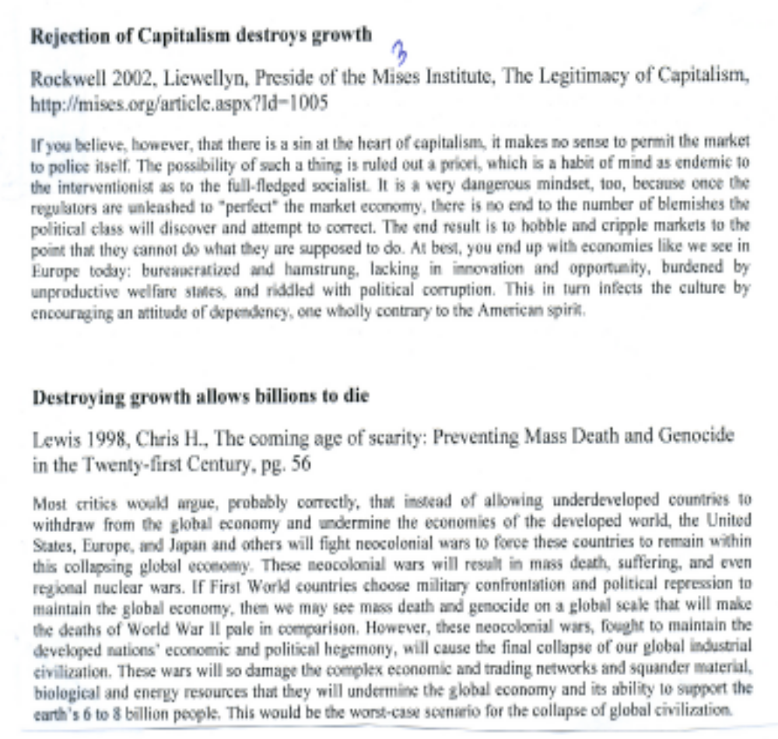
Aff: Transgression is Socially Irresponsible; Compassion is Better Alt
_____ They are commodifying Bataille’s academic musings, identifying with the transgressive, to win a debate. Refusing to imagine cooperative action with others is unacceptable given the context.

Tauchert in 2008
Ashley, Head of the English Department in the School of Arts, Languages and Literatures at the University of Exeter, Critical Quarterly, vol. 50, no. 1, April, pp. 17-18 (online at Wiley InterScience journal collection)

The intellectual engagement with questions of the final truth of human consciousness initiated by Bataille has been subsequently reified into a commodified critical desire to identify with the anguished and transgressive itself; a desire that has come to operate an unconscious fascination for academic thought, all the more compulsive as it is unconscious. By making the conditions of this thought conscious we can face it and decide what is to be done with it. Unconsciously motivated thought cannot be socially responsible thought, and we would do well to remember our responsibilities to each other and to the younger generation of thinkers. So this is also a book about power, the power of thought, and the power to generate and direct thought. The final concern of this work is to begin a process of understanding how it is that academic theorists can be so excited by transgressive thoughts, but dismayed by the effects of transgression in the social world.33 It is all very well and good to celebrate Bataille’s condensed image of the exorbitated eye: quite another thing to have one’s own eyes exorbitated. If this sounds naîve I am happy for it to be so, since to turn away from the fascinated, morbid play of critical transgression is finally to turn towards a conscious innocence that might just be more powerful in the end.

_____ Compassion is a better alternative than transgression. It both enables us to deal with the longing for substantiality and to imagine why the action of our advocacy is a good idea.

Tauchert in 2008
Ashley, Head of the English Department in the School of Arts, Languages and Literatures at the University of Exeter, Critical Quarterly, vol. 50, no. 1, April, pp. 120-121 (online at Wiley InterScience journal collection)

Renunciation of desire is no simple thing in practice, however, and arguably more suited to the life of a well-paid, highly reflective philosopher than of most subjects suffering the disorientating effects of virtual capitalism in their daily lives. But we do have to start somewhere, and where we are is always the best place. It is quite possible to accept insight into the longing expressed through transgression without making such a song-and-dance about its more mutilated, anguished expressions. It is also possible (if not ultimately inevitable) to experience this longed-for continuity without creating conditions of anguish and without entering the states of moral transgression which are favoured by the Bataillean school. This is what Kathy Acker realized in facing her own death consciously: I have become interested in languages which I cannot make up, which I cannot create or even create in: I have become interested in languages which I can only come upon (as I disappear), a pirate upon buried treasure. The dreamer, the dreaming, the dream.358
I think that Joy Davidman expresses the thought I am chasing here rather beautifully. She probably deserves, and would not expect to have, the last word: O agony, burn at my heart;
Burn at my heart and keep me warm.
Deliver me from the harsh iron of winter,
Unclothe me of the silver fur of frost,
Pare away the ice from the ends of my fingers.
Set me free of cold idleness
And deliver me from the barrier across my tongue
For I will say my word.
This is winter and I am imprisoned in it
With the tips of my fingers slowly turning to ice
But I shall not forget words
And the beautiful ringing of words linked together,
And I shall remember compassion
And keep the heart lit with a fire of pain
And let the sound of suffering made music
Whistle and sing in my throat until I die.359
Aff: Compassion Alternative -- AT: Sentimental and sickly
____ Compassion alternative to transgression is not mere sentimentality. But it avoids the lazy nihilism of transgressive thought.

Tauchert in 2008
Ashley, Head of the English Department in the School of Arts, Languages and Literatures at the University of Exeter, Critical Quarterly, vol. 50, no. 1, April, pp. 118-119 (online at Wiley InterScience journal collection),

The mode of emptiness-compassion I want to offer up against transgression is not a sentimental, sickly emphasis on suffering. It is the spontaneous selflessness that flows from an acknowledgement of the ‘emptiness’ of the ‘self’: and in this sense extends the thought of ‘continuity’ without linking it to its transgressive concomitants, ‘sacrifice’ and ‘anguish’. This idea might accept and complete the transgression of thought that Bataille attempted to put into motion through his work; acknowledging ‘the absence of reified selfhood’ without falling from there into the lazy nihilism of much critical transgression.350 Emptiness-compassion begins from the moment of realization that the self is not reifiable and does not exist ‘inherently’: The conclusion that the self does not exist at all is not drawn, but rather that the self is utterly unreifiable, non-inherently existent. Understanding this emphasizes the contingent, dependent, interconnected, and non-autonomous nature of the self’s existence. The self apprehended in emptiness-compassion theory is ‘associated with the development of a compassionate sense of relatedness in which self and other are seen not as oppositional but as relative designations, like the far and near banks of a river’ [Klein]351:
By becoming accustomed to the equality of self and other,
The spirit of enlightenment becomes firm.
Self and other are interdependent.
Like this side and the other side of a river, they are false.
The other bank is not in itself ‘other’;
In relation to someone else it is ‘this bank.’
Similarly, ‘self’ does not exist in its own right;
In relation to someone else it is ‘other’.352
Aff: Compassion Alternative – Transgression is Insufficient Experience
_____ Compassion goes beyond the moment of emptiness that transgression produces to liberation. It is a process of imaginative extension of feeling to the other.

Tauchert in 2008
Ashley, Head of the English Department in the School of Arts, Languages and Literatures at the University of Exeter, Critical Quarterly, vol. 50, no. 1, April, pp. 118-119 (online at Wiley InterScience journal collection),

‘Emptiness’, however, once experienced, is for the practitioner of ‘ultimate liberation’, not an end in itself: The insight into emptiness, facilitated by awareness, leads to an empowered compassion. The relationship between such insight and concern for others is an important principle in Mahayana Buddhism. Insight, and its affective counterpart, compassion, are crucial for the Buddhist enterprise of ultimate liberation. [Klein]346 The mode of liberation promised by transgression is always limited, momentary, fleeting, unsatisfactory: Orgasm has possessed the libertine; during the irreducible timelessness of the moment of orgasm, the hole in the world through which we fall, he has been as a god, but this state is as fearful as it is pleasurable and, besides, is lost as soon as it is attained. He has burst into the Utopia of desire, in which only the self exists; he has not negotiated the terms of his arrival there, as gentle lovers do, but taken Utopia by force. See, the conquering hero comes. And, just as immediately, he has been expelled from it, a fall like Lucifer’s, from heaven to hell. [Carter]347 By contrast, the ‘ultimate liberation’ offered through experience of ‘emptiness’, and the capacity for radical compassion it engenders, is unlimited by external conditions. It cannot be thwarted by the counterdesire of the other or the resistance of the object; it does not struggle to define itself against the constraints of necessity (‘reality’); and it is not, according to Bataille, limited by ‘the idea of a personal God.’348

Perhaps most importantly for this discussion, emptiness-compassion does not remain bound to an ambivalent desire for the (dead) maternal body as the ground of its becoming. Compassion is instead actively generated by the practice of imagining the other as the subject’s living mother:

Imagine your mother clearly in front of you . . . As your mother, she
protected you from all harm and provided you all benefit and happiness.
Particularly in this lifetime she carried you for a long time in her womb.
Then, when you were a helpless, newborn infant, she held you to the
warmth of her flesh and bounced you on the tips of her ten fingers. She
suckled you at her breast . . . and used her hand to wipe your excrement.
So in various ways she nurtured you tirelessly . . . Even more, what she
gave to you were not things that she had obtained easily but that she had
received through great hardship . . . In short, contemplate one-pointedly
how your mother provided help and happiness and cleared away harm
and suffering to the best of her knowledge and ability.349

It’s not supposed to be an easy exercise. Just the first step of imagining your personal mother’s particular sacrifices to generate, sustain and nurture the life of the subject you became is more difficult than it sounds on first reading. Close your eyes and try it for a moment. It will take a few goes to settle into the practice, and the results can be nauseating at first. Extending the feelings of compassion that result to the people closest to you is just about possible. Taking this further to apply those feelings to those you dislike or ‘hate’ and to the millions to whom you feel nothing much at all takes serious and sustained practice. The effects on the practising subject can be very interesting, but vary from person to person, so it is best to experiment rather than be told what to feel.
Aff: Transgression cannot recognize difference in mind-body experiences
___ The range of extreme experiences in transgressive thought is too narrow to encompass the mind-body continuum

Tauchert in 2008
Ashley, Head of the English Department in the School of Arts, Languages and Literatures at the University of Exeter, Critical Quarterly, vol. 50, no. 1, April, pp. 116-117 (online at Wiley InterScience journal collection),

Transgression has revealed an abiding longing for ‘continuity’ glimpsed in ‘limit conditions’ outside of the range of reason. This is an enduring and valuable insight, which has emerged from a profound intellectual reflection on the mind-body continuum, demonstrating how ‘limit’ experiences of the body can produce exciting new states of mind. It is conceivable, however, that the ‘limit’ states preoccupying critical transgression to date demonstrate only a very small part of the story that might be told concerning the mind-body continuum: The main thrust of Western intellectual history has avoided the discussion of the perfected human being. The focus has rather been on the universal, not the exceptional . . . today’s Western thinkers [are] more open to discussing the exceptional than were their predecessors, but, oddly, they examine mainly the negative side, that of the abnormal or diseased. Modern Western neurophysiology and psychoanalysis have opened the door to the extraordinary in human life, but only, as it were, the back door of the subnormal instead of the front door of the supernormal.340 Transgression is fixated on the publicly abjected extremities of human potential: madness, orgies, murder, rape, incest, ecstacy, s-m, death. Michel Foucault, according to James Miller, generated his most interesting ideas through experimenting with ‘unusual bodily sensations and altered states of consciousness’.341 Miller identifies the inspiration for Foucault’s mature intellectual work as an LSD trip in California. His companion on the trip recalls that at its height, with tears ‘streaming down his cheeks’, Foucault suddenly exclaimed: ‘I now understand my sexuality’.342 His sexuality was certainly very interesting, as was indeed Bataille’s. But there is no reason for those very particular (and in the most practical sense ‘limited’) ‘limit’ experiences to become definitive of the range and direction of critical thought to follow. The model of sovereign liberation forcing its way through
transgression may turn out in the long run to have been a retrograde step:
the conquest of morality and aesthetics, of shame, disgust and fear, the
pursuit of greater and greater sexual sophistication in terms of private
sensation lead them directly to the satisfactions of the child; transgression
becomes regression and, like a baby, they play with their own excrement. [Carter]343
Aff: Gender K of Transgression vs. Compassion Alternatives

_____ Transgression is almost exclusively a masculine practice. It is a fantasy that excludes women as reciprocal subjects.

Tauchert in 2008
Ashley, Head of the English Department in the School of Arts, Languages and Literatures at the University of Exeter, Critical Quarterly, vol. 50, no. 1, April, pp. 113-114 (online at Wiley InterScience journal collection),

Transgression has revealed itself to be an almost exclusively masculine critical preoccupation. Transgression as a respected intellectual tradition is the domain of male white Europeans. De Sade – Nietszche – Bataille – Foucault; an auto-affective genealogy that has incorporated otherness in the form of female bodies and female-embodied thought as the material resistance against which it forces its intellectual climax in a repetitive gesture that returns to the point of departure without the possibility of what Luce Irigaray – for whom ‘woman represents the emergence of the other with respect to Western tradition’ – would call ‘horizontal transcendence’.331 If ‘Transgression’ cannot be thought by the other, but only thinks of itself in violent domination or incorporation of otherness, through which it reaches its climax of autoaffective intensity, it can only really represent the logic of the same masquerading as a radical break with tradition. To make overt the core metaphor on which the theory of transgression attempts to close itself as a system is quite possible. Schehr explains that Lyotard, in his writing encounter with Bataille, had ‘a raging hard-on’; his ‘intensities gone wild’:

There is a homoerotic subtext of anal penetration . . . [c]ircles of men then
. . . [i]ntensities of prostitution, homosexuality, ultimately equivalent . . .
an orgy of exchange . . . homosexual fellation: a cosmic circle jerk.332

I wonder if the ‘intensities’ of prostitution really are equivalent to homosexuality? It seems very unlikely, unless Schehr means the intellectual prostitution of homosexual desires. In any case, this intellectual figure of a ‘cosmic circle jerk’ by necessity excludes women except as objects – rather than reciprocal subjects – of representation or thought. Women would break the circle. Julia Kristeva has already noted that Bataille explores openly the ‘subject/object relationship (and not subject/other subject)’ that is ‘rooted in anal eroticism’.333 Now, I’ve nothing against ‘anal eroticism’ in itself, but wonder whether this is the best – or only – way we might order our critical work.
Aff: AT: Do Both Transgression and Compassion
___ Compassion is intellectually competitive with transgression. Compassion asserts the irreducible truth of the other and transgression centers on the sovereign imaginary.

Tauchert in 2008
Ashley, Head of the English Department in the School of Arts, Languages and Literatures at the University of Exeter, Critical Quarterly, vol. 50, no. 1, April, pp. 115 (online at Wiley InterScience journal collection),

Compassion is the ‘enemy’ of transgression in the simple sense that compassion recognizes the irreducible truth of the other in any encounter, critical or otherwise, while transgression centres on the inner experience of a sovereign will-to-power; masterhood. Angela Carter’s searing analysis of de Sade exposes the particular condition of Sadean transgression as the denial of the possibility of love: ‘The libertine’s perversions are the actings-out of his denial of love’.337 The maternal body is the primary object of transgression because transgression is always regressive in its tendencies, pushing back the ordering injunctions of the fundamental, maternal ‘architecture’ that structures the subject’s individuation. The excremental enthusiasm of the libertines transforms the ordure in which they roll to a bed of roses. The pleasure of the libertine philosophers derives in a great part from the knowledge they have overcome their initial disgust. By the exercise of the will, they have overcome repugnance and so, in one sense, are liberated from the intransigence of reality. This liberation from reality is their notion of freedom.338 [Carter]

____ Compassion avoids their dilemma between transgression and regression.

Tauchert in 2008
Ashley, Head of the English Department in the School of Arts, Languages and Literatures at the University of Exeter, Critical Quarterly, vol. 50, no. 1, April, pp. 116-117 (online at Wiley InterScience journal collection),

Kathy Acker knew that for de Sade women can ‘transform (. . .) themselves into men by choosing to engage in sodomy’: ‘In sodomy, the most delicious position is the passive one. In other words, a woman can know freedom by choosing to counterfeit a man who selects the bottom power position.’335 I’m not convinced by this model of freedom: it seems rather limiting for women to counterfeit the freedom of homosexual men. If criticism is personal to the point of performing unconscious desires, it should also be possible to direct the process in accordance with some form of moral consciousness (restraint) without capitulating to regressive tendencies or reducing desire to instrumentalized productivity. This section takes the form of a ‘Preface to Compassion’ against ‘Transgression’ as an experiment in shifting the discussion beyond the transgression/regression impasse. If transgression overcomes the other in its drive to achieve a sovereign state of continuity, intensified by breaches in a fundamental moral ground for human individuation, compassion might just offer an equally bracing model of radical liberation, and one less jarring to maternal subjectivity.

